|  |  |
| --- | --- |
| Pet-farmer Killer  Prof: Tansel Halic | moise mokoy  Game Design Proposal |

**GAME CONCEPT**

**DESCRIPTION**

The pet-farmer Killer is a survivor action game. The game is about a farmer who in order to survive he has to kill the animals in his farm. This is a first person shooter game, fast-paced focused on action.

The player must must not only survive, but try to kill as many animals as possible to earn points to achieve the level. The animal will appear each eight seconds so the more animal you kill the better you will have a chance to survive or pass the level. The player will have gun to use during the game and the player will be able to collect lives, ammo, and change gun during the game.

**MINIMUM SYSTEM REQUIREMENT**

* Platform: PC
* Mouse
* keyboard

**GAME MECHANICS**

**SAMPLE GAME PLAY**

The game will start with the player alone at the field. The player will have eight seconds the find a cover before the animal started to appear. Player has to shoot the animals to gain points. There will be four different animals during the game: chicken, cow, sheep, and pig. After eight second 4 new animals will be appearing on the fields. So this is fast pace game. The player will have to use a rocket or a shotgun to kill as many animals as possible. The player can walk or run during the match, but running will be the best option. After the player reaches 2000 points, the boss will appear. The boss will look like a 10x pink sheep. During that time, the animals will continue to appear on the game until the player reaches 5000 points and kills the boss to complete the game.

**GAME MODES**

Level One

In level one, the match will have only two types of animal, Chicken and pig. The player will have to reach 5000 points and kill the boss to pass the level. The match will happen in daytime. The animal will be moving at the normal speed. So level one will be easy so the player will learn how to chose and move during the game.

Level Two

The game will be harder. The player has to play smart because the number of animal will increase to four, and there will be faster and harder to kill. The design will be the same as level one. To finish level two, the player has to reach 7000 points and kill the boss.

**PLAYER DESIGN / CHARACTERS**

First Person Shooter

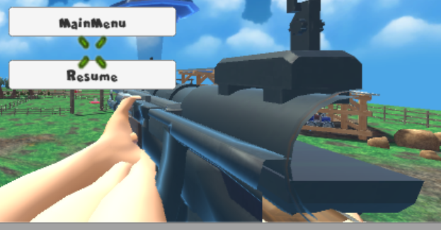

In this game, I used the first person controller. Only the gun and hand will be visible during the game. The player is able to walk, run, jump and shoot during the game.

**PLAYER WEAPONS**

ShotGun

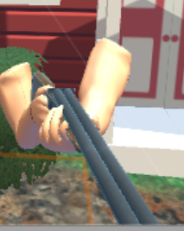

* 30 bullets
* 10 bullets for the Ammo
* Short Range

Ak47



* 75 bullets
* 30 bullets for the Ammo
* Long Range

Rocket

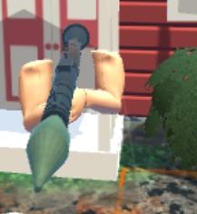

* 10 rockets
* 10 rockets for the Ammo
* Long Range

HandGun

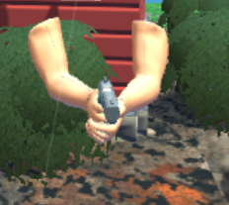

* 75 bullets
* 30 bulets for the Ammo
* Short range

**ANIMALS**

Cow

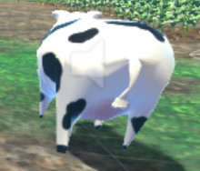

* Health: 10
* Damage: 7

Pig

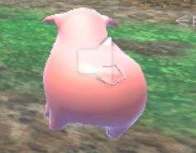

* Health: 5
* Damage: 5

Chicken

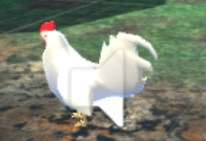

* Health: 2
* Damage: 2

Sheep

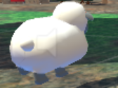

* Health: 20
* Damage: 10

Red Sheep

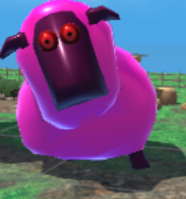

* Health: 200
* Damage: 20

**PHYSICS**

Terrain

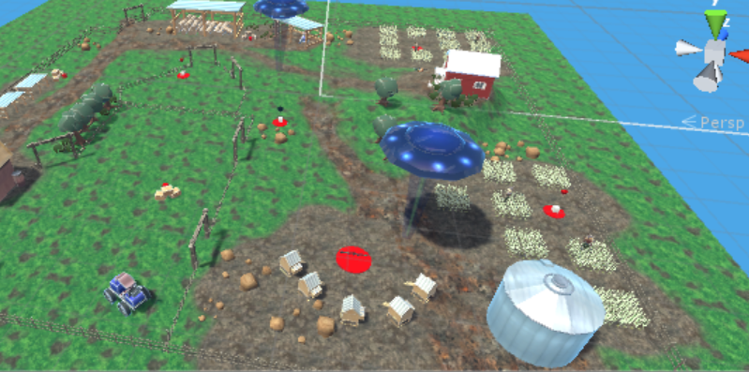

The farming place will look like a rural place. Object used in this game came from object we found in the farming place.

**ARTIFICIAL INELLIGENCE DESIGN**

AI NavMesh Agent is used in this game control the movement of the Animal. The animal will be able to detect the player on the fields. The enemy can have many behaviour. There will be different motion behaviors for each animal

**PLAYER INTERFACE**

**HEADS UP DISPLAY**

As a first person shooter style game, Pet Farmer Killer relies heavily on having a clear view for user detect animals. User interface elements is minimize to allow the player to have a clear view onto the action.

The User Interface will contains:

* Enemy: which shows the number of enemy that are alives
* Points: number of points collected
* Ammo: number of ammo collected
* Health: Player health
* Armor: Player armor

**TECHNICAL ANALYSIS**

**CHALLENGES**

* AI: implement the AI is always challenges. The details you want the AI to handle sometime don’t work. I spend hour on youtube to try to understand the navmesh and make sure flow is right between the enemy and the player.
* Scripting: This is always a challenges. I was able to find some references on internet but it was hard to implement some part in my game.
* Time: as I decided to make a new game, I didn’t have enough time to create a fun game game. Time played a big part because this game required a lot of attention and focus that I wasn’t able to give because of other tasks.

**TIMELINE**

* Midtem One: March 9, 2018
  + Graphics Engine: 40%
  + Physics Engine: 20%
  + AI Engine: 10%
  + UI Engine: 0%
* Midtem Two: April 9; 2018
  + Graphic Engine: 70%
  + Physic Engine: 60%
  + AI Engine: 40%
  + UI Engine: 45%
* Final prtoject: May 5; 2018
  + Graphic Engine: 90%
  + Physic Engine: 80%
  + AI Engine: 80%
  + UI Engine: 90%